- Keir Starmer resigned as UK prime minister this week and looks likely to be replaced by Andy Burnham from mid-July. Markets have been unfazed by events so far, but we think many market participants are instinctively wary of Burnham given his previous comments. This means any missteps could see sentiment move against the new government, and Burnham’s choice of chancellor will be the first big test.
- We expect that short-end pressures will continue to fade. The oil price has fallen further this week, while June’s flash PMI survey reported soft activity. In a speech, Monetary Policy Committee dove Alan Taylor put forward a compelling argument for why the risk of second-round effects from the energy shock is much lower than it was in 2022, and we think this view is shared by the majority of the MPC.
The UK will soon have its fifth prime minister in five years. Keir Starmer announced his resignation as Labour leader and prime minister on Monday, the same day that likely successor Andy Burnham was sworn in as an MP after winning last week’s Makerfield by-election. As things stand, it looks unlikely that any other Labour MP will stand for leader, so Burnham is set to become prime minister shortly after the July 16 deadline for leadership nominations.
So far, markets have taken events in their stride. At market close on Thursday, 10-year government bond spreads against both US treasuries and German bunds were at similar levels to a week earlier and well below the levels seen before the US-Iran deal was announced (Chart 1). Though sterling has depreciated against the dollar, this appears more a story of dollar strength than sterling weakness, given the pound has held steady against the euro.
Chart 1: Markets have responded calmly to news of Keir Starmer’s resignation as prime minister
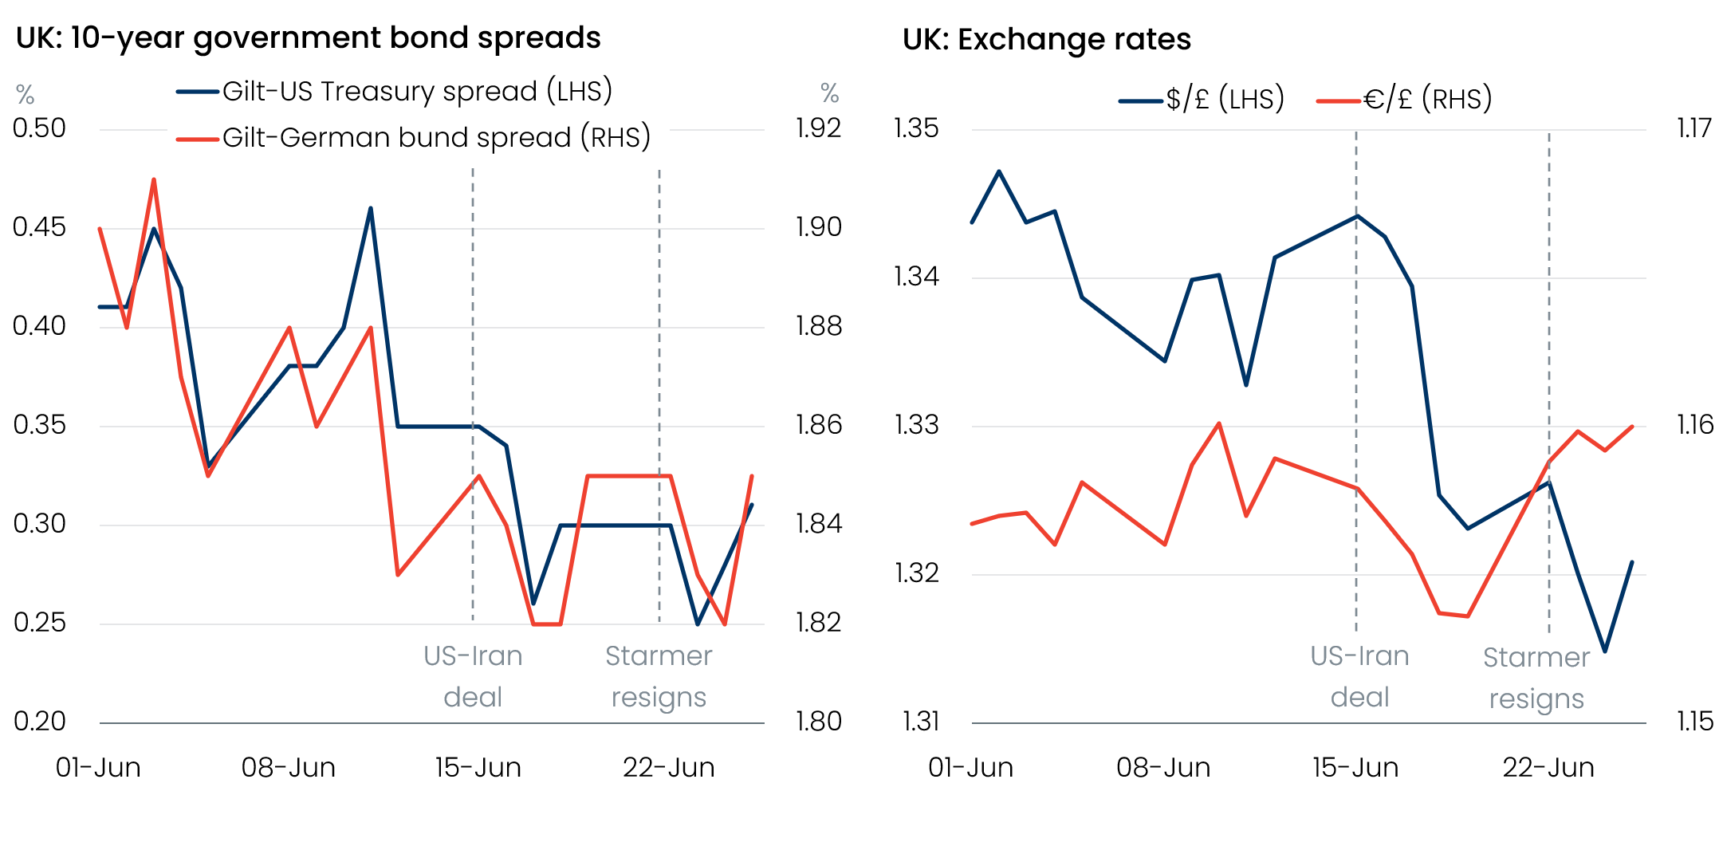
Source: Haver Analytics

Whether markets remain sanguine will depend on how perceptions of Burnham’s likely approach to fiscal policy evolve. We think that markets will be instinctively wary of Burnham because he has previously advocated costlier left-wing economic and fiscal policies and made critical comments about the role of bond markets. So any missteps with his messaging are likely to steepen the yield curve.
One of the key early signals is likely to be Burnham’s choice of chancellor. One of the reasons why markets were willing to give the current administration the benefit of the doubt, despite unconvincing fiscal plans, was the view that Chancellor Rachel Reeves was fully committed to her fiscal rules. Given her close association with Starmer and low opinion ratings, it’s almost certain that Reeves will be replaced. Media speculation involves many potential candidates with a wide range of views, and Burnham’s choice will send a strong signal about the direction of travel under his leadership.
This autumn’s Budget will be the next landmark. But given the pace at which events have unfolded in recent weeks, it’s unlikely that Burnham’s team has a detailed policy package ready to go. A change of chancellor will add to the time constraints. So we think there’s a good chance that ‘Burnamism’ could be more of a slow burner. At this stage, we see no reason to change our growth forecasts in response to domestic political developments.
Pending approval from the Treasury Select Committee, it was announced this week that this autumn’s Budget will be refereed by Jonathan Haskel, in his role as the new head of the Office for Budget Responsibility. Haskel was previously an external member of the Bank of England’s Monetary Policy Committee and an academic. One of his research specialisms has been productivity, an area where the OBR’s forecasting has come in for particular criticism, so it will be interesting to see whether Haskel’s influence leads to some forecast changes.
Turning to monetary policy, Haskel’s successor on the MPC, Alan Taylor, gave a speech at the Barclays-CEPR Monetary Policy Forum this week. The speech was ostensibly about the role of the MPC’s central forecast, but the most interesting aspects were Taylor’s take on the current conjuncture. Taylor followed the lead of fellow external member Megan Greene by comparing a range of variables at the start of this energy shock with previous shocks. But his conclusion was different, arguing that we entered this shock with a very weak economy with plenty of slack. He also cited the breakdown in the correlation between firms’ expectations for prices – both their own and CPI – and pay growth in the BoE’s Decision Maker Panel as evidence that this slack is having an impact (Chart 2).
Chart 2: The correlation between firms’ expectations for prices and wages has weakened this year
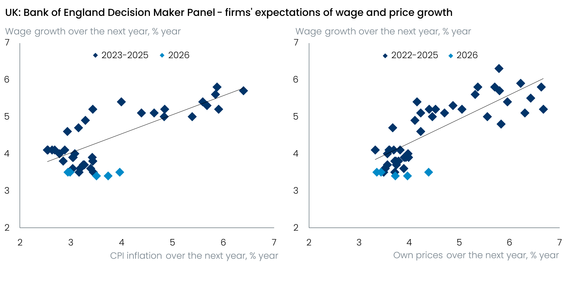
Sources: Oxford Economics, Haver Analytics
Taylor has long been at the more dovish end of the MPC’s spectrum, so his conclusions weren’t a surprise. But we found the data he presented to back his view was more compelling than Greene’s recent effort.
One factor that will complicate the MPC’s assessment of the strength of the labour market is the Office for National Statistics’ latest problems with its Labour Force Survey. For some time, the ONS has been running the LFS in parallel with its eventual replacement, the Transformed LFS. But the ONS has discovered that it allocated too many of its staff to the TLFS between early-May and mid-June, leaving it with a reduced sample for the LFS. We already had big question marks over recent LFS data given the significant volatility – single-month estimates for unemployment have varied by 0.8ppts over the past three months. The latest mess further knocks our already-fragile confidence in the reliability of the ONS data.
But looking past these data problems, it remains hard to find reasons why the MPC would tighten policy. The oil price continued to fall back this week, June’s flash PMI survey reported soft activity, and the Citi/YouGov survey reported a large fall in year-ahead inflation expectations. But while short-end pressures should continue to fade, we think there’s a good chance that the yield curve will steepen as markets consider the potential for fiscal slippage under Burnham.

The week ahead
We expect the May Money and Credit release from the Bank of England will confirm that April’s spike in mortgage approvals was an anomaly caused by seasonal adjustment around Easter. Underlying conditions have worsened significantly in recent months, with quoted mortgage rates up 90bps-100bps on the levels seen before the Middle East conflict. We expect this to be reflected in mortgage approvals for house purchase falling back to 62,900 in May from 65,900 in April. But net mortgage lending should pick up, after April’s outturn was pushed down by very high levels of repayments.
Net unsecured lending has been firm in recent months, reflecting a surge in non-credit card gross lending and a dip in credit card repayments. But we expect both trends to have partially reversed in May, dragging net unsecured lending down to £1.5bn.
On Tuesday, the Office for National Statistics will publish the Quarterly National Accounts for Q1 2026. This will see the ONS take a second stab at estimating GDP, with its initial estimate having shown strong q/q of 0.6%. The release will also provide the first estimates for household income growth and the saving ratio for Q1.
Table 1: Week ahead calendar
Date | Events | Period | Measure | Unit | Previous | Forecast
Jun 29 | Mortgage approvals | May | Level | 000s | 65.9 | 62.9
Jun 29 | Mortgage lending | May | Net lending | £bn | 4.4 | 4.9
Jun 29 | Consumer credit | May | Net lending | £bn | 1.9 | 1.5
Jun 30 | GDP | Q1 | q/q | % | 0.6 | 0.6
Jun 30 | GDP | Q1 | y/y | % | 1.1 | 1.1
Jul 1 | Nationwide house prices | Jun | m/m | % | -0.6 | 0.0
Jul 1 | Nationwide house prices | Jun | y/y | % | 1.7 | 2.4
Jul 1 | S&P Global manufacturing | Jun | PMI | % bal | 53.1 | 53.1
Jul 3 | S&P Global services | Jun | PMI | % bal | 48.7 | 48.7
Jul 3 | S&P Global composite | Jun | PMI | % bal | 49.4 | 49.4
Source: Oxford Economics

Key forecasts
Table 2: UK forecast overview
(ANNUAL PERCENTAGE CHANGES UNLESS SPECIFIED)
 | 2024 | 2025 | 2026 | 2027 | 2028 | 2029
GDP | 1.0 | 1.4 | 0.9 | 0.8 | 1.8 | 1.7
Private consumption | -0.1 | 0.8 | 0.7 | 0.6 | 1.5 | 1.8
Fixed investment | 1.7 | 4.3 | 0.3 | 1.5 | 2.5 | 2.1
Government consumption | 2.9 | 1.6 | 1.3 | 1.6 | 1.4 | 1.2
Consumer prices | 2.5 | 3.4 | 3.1 | 2.5 | 1.9 | 2.0
Unemployment rate (%) | 4.3 | 4.9 | 5.4 | 5.6 | 5.1 | 4.7
Current a/c balance (% of GDP) | -3.0 | -2.4 | -4.1 | -3.3 | -2.8 | -2.6
Government balance (% of GDP) | 5.2 | 5.0 | 3.6 | 3.6 | 2.9 | 2.6
Central bank policy rate (%, EOP) | 4.75 | 3.75 | 3.75 | 3.50 | 3.00 | 2.75
10yr govt. bond yield (%, EOP) | 4.57 | 4.47 | 4.97 | 4.43 | 3.82 | 3.57
Exchange rate (US$ per £, EOP) | 1.25 | 1.35 | 1.30 | 1.30 | 1.30 | 1.30
Exchange rate (euro per £, EOP) | 1.21 | 1.15 | 1.12 | 1.10 | 1.10 | 1.10
Source: Oxford Economics
Table 3: Quarterly forecasts for the UK
 | 2026 |  |  |  | 2027
 | Q1 | Q2 | Q3 | Q4 | Q1 | Q2 | Q3 | Q4
GDP (% year) | 1.1 | 1.0 | 0.7 | 0.6 | 0.3 | 0.5 | 1.0 | 1.3
CPI inflation (% year) | 3.1 | 2.8 | 3.2 | 3.4 | 3.2 | 2.7 | 2.2 | 1.9
Bank Rate (%, EOP) | 3.75 | 3.75 | 3.75 | 3.75 | 3.75 | 3.75 | 3.75 | 3.50
10yr gilt yield (%, EOP) | 4.88 | 4.90 | 4.99 | 4.97 | 4.92 | 4.79 | 4.62 | 4.43
US$ per £ (EOP) | 1.32 | 1.34 | 1.32 | 1.30 | 1.30 | 1.30 | 1.30 | 1.30
Euro per £ (EOP) | 1.14 | 1.16 | 1.14 | 1.12 | 1.11 | 1.10 | 1.10 | 1.10
Source: Oxford Economics

Latest Country Economic Forecast:
Jun 19, 2026

Recent publications

Data Insights
June’s drop in the PMI consistent with softer momentum in Q2
Retail sales bounced back in May
Government borrowing already off track
Labour market remains loose
Another downside surprise for inflation

Research Briefings
Yield curve likely to steepen as the UK changes prime minister again
The MPC remains firmly in wait-and-see mode
MPC preview – Another hold, but the door will be kept open to hikes
Is a more optimistic view on recent productivity trends justified?
Debt predicament – structural weakness and a credibility deficit

Contacts

Oxford Economics' UK team
- Andrew Goodwin – Chief UK Economist – agoodwin@oxfordeconomics.com
- Edward Allenby - Senior UK Economist - eallenby@oxfordeconomics.com

